-TIPS FOR GOOD TUTORIAL CREATION-

* The less text the better - text generally ruins the pacing and immersion of a game, and will often be skipped by those players that need it the most
* The tutorial should be interactive (hands-on) - the players should play through the actions they need to learn, and this will help them to understand what the tutorial is trying to convey.
* Don’t front load your tutorial - it is not necessary to deliver every piece of information that your player will ever need, right at the start of your game
  + By doing this, you will overwhelm your player with information and undersupply them with engagement
  + It also risks the player forgetting information by the time it is needed, and they are more likely to get bored of your tutorial
  + It is far more beneficial for both designers and players to introduce gameplay elements as they become important, the player gets into the game quicker, the information is given in digestible chunks and they will get to start practicing what you taught them as soon as possible
  + If there are elements of UI or menu screen that won’t be used by the player for the first 30 minutes of gameplay, don’t clutter your screen with them from the start
* Make the tutorial fun - people learn better when they are having fun, so your tutorial should be exciting, interesting and just as engaging as any other part of the game
  + If you can’t grab the player in the first 10 minutes of gameplay, then you are going to lose a large part of your audience
* Reinforce learning through play - reinforce things taught during the tutorial by highlighting their use in gameplay but do not make it overly telegraphed
  + It is important to help the player understand how to apply the tools they learnt about in the tutorial during actual gameplay
* Give feedback to users, as users need to know how well they are doing.
  + Things like progress bars, levels and encouragement messages will motivate the player to complete the tutorial.
* Listen to your players - your tutorial is probably the most important thing in your game to playtest (it is easy to believe something is intuitive when you’ve been developing it over time)
  + Don’t talk to your players during this process, but watch where they get stuck and what they have trouble with, then listen to what they say to you after that before asking questions
  + Be mindful of your demographic - what may be second nature to you may not be so for the people in your demographic
    - Not everyone will be familiar with the conventions that you are using
* Tutorials should be skippable or shouldn’t interrupt the flow of play - you don’t want to have to force everyone to sit through your tutorial every time they start the game again
  + Manage frustrations, be aware of possible users’ frustrations and anticipate user errors when crafting your tutorial.
* Anything you put in the tutorial should always be accessible - it doesn’t have to be in any deeply immersive fashion, but simply including a help encyclopaedia in the options menu or access to how-to videos from the pause screen will go a long way
* It is important to keep the player engaged in the tutorial of the game, this can easily be achieved by giving players rewards for completing tasks in tutorial.
  + Giving players rewards, causes or brain to release quick doses of dopamine; this motivates players to continue playing the game, and come back later.

Sources

<https://www.youtube.com/watch?v=BCPcn-Q5nKE&vl=en>

<https://www.gamified.uk/2017/10/19/gamification-lessons-candy-crush-soda-saga/>

-PLAYER ONBOARDING-

↳ 3 fundamental user onboarding lessons from Nintendo

↳ ① Teach the game by playing the game (show don’t tell)

↳ Learning by doing, i.e. immediate practicing, provides a 75% retention rate for learning as oppose to reading or audiovisual which provides <20% retention rate

↳ don’t drop users into an empty dashboard, you need to onboard the users so that they learn how to use your product and become experts

↳ know which core features you want users to be fluent in and present these upfront

↳ ramp up complexity progressively, a progressive increase in difficulty that corresponds with progressive increase in complexity if a common game mechanic

↳ ② Design for the naive user

↳ user testing is important; gain personal insight about your user and test your designs by having them carry out tasks without intervening (important to reach out to people who are not experienced with your game/product)

↳ ③ Inspire users to progress

↳ the “need to complete” is one of the most important psychological drivers of game engagement

↳ Russian psychologist Bluma Zeigarnik found that while uncompleted tasks stick in a person’s memory, completed tasks are more easily forgotten, so when you pursue a task but leave it unfinished, your brain will keep bugging you about it until it’s done

↳ could give the player quests that require them to grow an object, will encourage them to come back to the game to complete the task which will instantly be replace when they receive a new incomplete task

↳ **add progress indicators to your onboarding process**; this plays into 4 of the 7 components of gamification by giving users a sense of purpose, defining the rules of progress, providing visual feedback, and motivating users to act through intrinsic motivation

↳ **remind users of an incomplete task on multiple channels**; in-app make the progress bar and add unfinished steps, send notifications to re-engage users who have been idle for a while

↳ **weave incomplete tasks throughout your entire user journey**; many apps use mission-based approaches and ongoing progress meters to perpetually inspire re-engagement

↳ Onboarding is about teaching users the rules and tools to play the game, and starts as soon as the user downloads/signs up to your game

↳ Creating an identity

↳ video games make you who you are, they reflect your ideas and your behaviours

↳ most games allow players to create a profile, character and choose your own way to do things, giving a great sense of freedom as you can do whatever you wain in the specific world

↳ this is a great onboarding strategy, as it gives users the possibility to create an identity and, in many cases, a character affects the user psychologically

↳ Glowing choice

↳ the use of glowing choices can be used to display hints to the user about what to do next

↳ players can be forced to click a glowing choice by limiting theirs options and greying features out, but it is often more empowering to get the user decide what they wish to do

↳ another option is to allow the player to explore by not forcing them to click the glowing choice, but it will remain until the user does click on it - eventually the player will click it and will be ready for the next step

↳ Introduce early win-states

↳ small achievements need to be rewarded frequently at the beginning as these will build player’s confidence

↳ it is important to introduce as many of these opportunities as possible as conquering minor challenges can be very satisfying for new players

↳ harder challenges need to be introduced gradually as the game progresses past the onboarding phase

↳ Create a hands-on onboarding experience

↳ **think about how you are going to teach users how to use a particular feature** as you design it, making it as intuitive as possible should always be your goal

↳ be aware of **possible user frustrations** and anticipate **potential user errors** when crafting your tutorial

↳ **progressively teach the user new things**, by building on previous experiences and knowledge, paying attention to the order and context of each piece of information

↳ **empty state screens** are a great moment to teach users the **goal of the screen and invite them to complete and action** - they should always explain why they are empty and invite the user to do something about it

↳ watch your users go through your onboarding process, see if their expectations are being met, or if they are getting frustrated and when

↳ as you release new features, you need to teach your users how to use them, the best time to do this is when it is valuable to the player

-ENGAGEMENT LOOP AND PLAYER LIFECYCLE-

↳ 7 components of gamification

↳ **Goals** - give users a sense of purpose, and accomplishment. Grading should be accumulative rather than reductive. Scores should not go down, only up (unless you are truly trying to punish player).

↳ **Rules** - repetitive, continuous limitations give users structure. Make sure that rules are clear and players know what needs to be done and how it needs to be done.

“Once players realise what they need to do, it becomes their game.” ~Shigeru Miyamoto.

↳ **Rewards** - reward users for their time and effort through badges, points, leaderboards, etc. Players like to be rewarded for what they do, otherwise what is the point of something that doesn’t pay off? Introducing early win states increases player motivation, and makes them feel that they are doing well.

↳ **Motivation** - give users a reason to act through intrinsic or extrinsic motivation (e.g. curiosity or praise, respectively).

↳ ***Intrinsic Motivation*** - this is when we act without any obvious external rewards. We simply enjoy an activity or see it as an opportunity to explore, learn and actualize our potentials (curiosity).

↳ ***Extrinsic Motivation*** - this is usually defined as our tendency to engage in activities in order to gain some type of known, external reward (praise).

↳ **Feedback** - show users their progress through progress bars, levels, animations, etc.

↳ **Freedom of choice** - users enjoy systems they’ve opted into more than those they’re forced to participate in.

↳ **Freedom to fail** - give users the opportunity to try again when they fail.

Sources

* <https://celiahodent.com/the-gamers-brain-part-2-gdc16/>
* <https://medium.com/@alper/engagement-loops-are-the-best-way-to-motivate-people-using-game-mechanics-a0deeb9a2afc>
* <https://medium.com/@madebysan/hands-on-onboarding-lessons-from-game-design-941ab4ce8e98>
* <https://medium.com/helppier/what-video-games-taught-us-about-user-onboarding-cc4624ce63d0>
* <https://www.appcues.com/blog/3-fundamental-user-onboarding-lessons-from-classic-nintendo-games>
* <https://www.verywellmind.com/what-is-extrinsic-motivation-2795164>
* <https://www.verywellmind.com/what-is-intrinsic-motivation-2795385>
* <https://yukaichou.com/gamification-study/4-experience-phases-gamification-2-onboarding-phase/>
* <https://positivepsychologyprogram.com/positive-emotions-list-examples-definition-psychology/>
* <https://www.gamasutra.com/blogs/BenLewisEvans/20130827/198975/>
* <https://www.psychologytoday.com/gb/blog/the-compass-pleasure/201110/video-games-can-activate-the-brains-pleasure-circuits-0>
* <https://www.learning-theories.com/dopamine-games-motivation.html>
* <https://www.whatgamesare.com/vertical-slice.html>
* <https://www.slideshare.net/amyjokim/gamification-101-design-the-player-journey/98-Virtual_Economies_drive_ongoing_use>

-PLAYTESTING COMMENTS-

* “Would be nice to have a small enemy ship rather than a flag. You should be able to see a cannonball leave the enemy ship”
* “Clearer instructions on what to do, the D-Pad icon needs to be clearer as I did not know how to pick up items initially”
* “Two torches would be useful, I sometimes found myself waiting for my gameplay partner to finish using the torch and would be left with nothing else to do while waiting”
* “The difficulty between the tutorial and the main game level ramps up far too quickly”

-IDEAS FOR ITERATING THE TUTORIAL-

* Design for the naïve user
  + The D-Pad icon in the middle of the hold is unrecognisable on first look, ensure that this is obvious to players
    - Rather than the icons for each object covering the corresponding part of the D-Pad, show the D-Pad icon in full and have each object at the end of their corresponding direction
  + The signs above the cannons need to be far more obvious for the player
    - These need to be angled so that they are easily visible to the player
    - These need to be larger so that it is immediately obvious what the cannon is missing
  + It is not immediately obvious which button should be used to interact with objects, such as loading the cannon
    - The area in which the player can be standing in to load objects into the cannon should be larger
  + It is not immediately obvious to the player that they are required to stand in place for a certain amount of time to load the cannons
    - Every other action requires a tap of a button - how could we indicate to the player that they are required to interact with an object for the set amount of time, which also helps them to understand the purpose of the UI circle beneath their character?
    - Could force the player to stand in place for the first time but this eliminates the idea of freedom of choice
  + It is not obvious that you are holding an object
    - There could be an icon displayed above the characters head to display what each player has in their hand
* Need more clear instruction of exactly what the player needs to do
  + Use glowing objects to guide the player through the exact steps they need to take, this in conjunction with more obvious UI should solve a lot of problems
  + Could include a visual instructions pop-up that demonstrate to the user which buttons perform which actions
* Progress indicators for how far the player is through the tutorial
  + Could be a simple visual bar that indicates how much of the tutorial is complete and could motivate the player to finish the remainder of the level

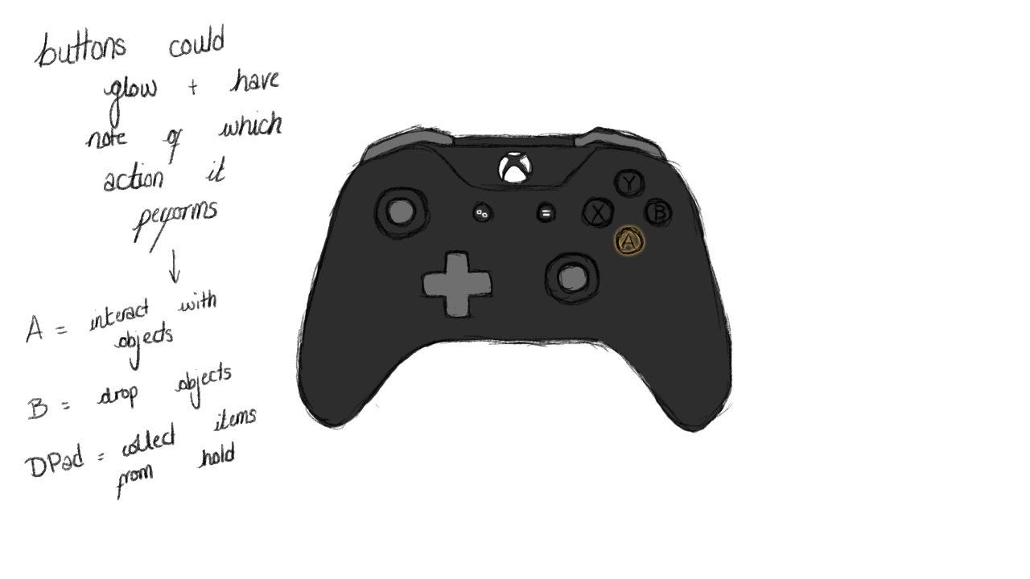

Figure : Instructions mock-up, controller diagram would be at the centre of the screen and buttons would glow in order with a note to display which action each button performs